18.78: a) The two degrees of freedom associated with the rotation for a diatomic molecule account for two-fifths of the total kinetic energy, so 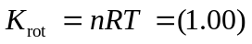

- 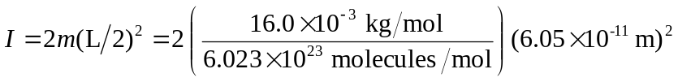

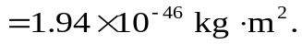

- Using the results of parts (a) and (b),

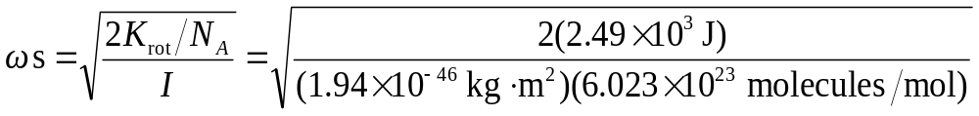

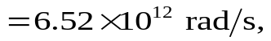

much larger than that of machinery.

